
Muma College of Business
School of Information Systems and Management

Data Visualization
ISM 6419.901F23 – FALL 2023
Prof. Johannes Han Reichgelt, PhD

Final Project Report
Chronic Disease Management
By
Madhumitha Jeripothula
U05948621
Business Analytics and Information Systems

INTRODUCTION:

The project focuses on chronic diseases in the United States, with a specific emphasis on the year 2017. Chronic diseases are persistent, long-term conditions that often require ongoing medical attention and can have a profound impact on individuals' health and well-being. These diseases, such as heart disease, diabetes, and chronic respiratory conditions, etc are major contributors to morbidity and mortality worldwide. In the context of the United States, understanding the prevalence, distribution, and implications of chronic diseases is crucial for public health planning, resource allocation, and the development of effective interventions.

The project aims to provide a nuanced and accessible portrayal of the complex landscape of chronic diseases in the U.S. during the year 2017. This involves integrating diverse datasets, including demographic information, regional variations, and specific disease prevalence rates, to give a holistic perspective on the challenges posed by chronic conditions.
The project's challenge is to gather and analyze a lot of data to get a complete picture of chronic diseases. The main questions we're trying to answer are:
- How many people had chronic diseases in the U.S. in 2017?
- Did it affect some groups more than others?
- Are there certain areas where these diseases are more common?

The goal is to provide insights that inform public health strategies. By understanding the landscape of chronic diseases, we aim to identify areas of concern, disparities in healthcare access, and potential interventions. The use of Tableau allows us to translate complex data into accessible visuals, contributing to a more profound comprehension of the impact and prevalence of chronic diseases in the U.S. in 2017.

METHODOLGY:

In this project, we meticulously gathered data from diverse sources to build a comprehensive understanding of chronic diseases in the United States during 2017. Our primary data sources include reputable national health databases, such as the Centers for Disease Control and Prevention (CDC) and the National Center for Health Statistics (NCHS). These organizations provide extensive and reliable information on disease prevalence, demographic factors, and health behaviors, forming the backbone of our dataset.
To ensure a nuanced exploration, we also incorporated regional data from state health departments and local health agencies. This granular information allows us to identify specific geographic patterns and variations in chronic disease prevalence. Integrating these factors into our analysis contributes to a more holistic understanding of the relationship between lifestyle choices and chronic diseases.

Datasets used in this project:

Main_deaths_2017 dataset:
Attributes:
Year: The year in which the data was recorded
Cause Name: Specifies the specific cause of death.
State: Indicates the geographical location (state) where the death occurred.
Deaths: The total number of deaths for a particular cause in each state.
Age-adjusted Death Rate: Represents the death rate adjusted for age, allowing for accurate comparisons across populations.
Race Name: Describes the racial category associated with the deaths.
Age Category: Categorizes the deaths based on age groups.
Death Value: Provides the numeric value associated with the deaths.

Main_data_2017 dataset:
Attributes:
Year: This field indicates the specific year in which the health-related data was collected or recorded.

LocationAbbr: This abbreviation likely represents a shortened form or code for the geographic location being referred to. It could be a state code or another identifier.

Location: This field provides the full name or description of the geographic location corresponding to the abbreviation, offering clarity about the specific area under consideration.

Topic: This field likely denotes the overarching subject or theme of the health-related data. It provides context about the nature of the information being measured.

Question: This field specifies the health-related question or inquiry to which the data corresponds. It helps to understand the specific aspect of health being assessed.

Data Value: This numeric field holds the actual numerical value or percentage representing the health-related metric being measured. It provides the quantitative aspect of the data.

Stratification Category: This field refers to the overarching category under which the data is stratified or segmented. It could be demographic information, age groups, or other relevant categorizations.

Stratification: This specifies the specific subgroup or stratum within the chosen category. For instance, if the category is age, the stratification might represent different age groups.

Geolocation: This field likely contains geographical coordinates or information that precisely locates the specified area on the Earth's surface.

Location ID: This is likely a unique identifier or code assigned to each specific geographic location, providing a standardized way to reference and organize the data.

Topic ID: Similar to Location ID, this field likely serves as a unique identifier for the overarching health-related topic or theme, facilitating systematic organization and retrieval of data.

Death_data_final dataset:
Attributes:
Country_Code: A code uniquely identifying each country.
Country Name: The name of the country associated with the data.
2017_DeathRate: The death rate specifically for the year 2017.
Region: Classifies countries into regions based on geographical proximity and similarities.
IncomeGroup: Categorizes countries into income groups, providing insights into economic status.
Year: The year associated with the death rate data.

ANALYSIS:

- CHRONIC DISEASE DEATHS BY EACH STATE, USA:

The graph shows the number of deaths by state in the United States by cause for the year 2017 available. The top 5 causes of death are heart disease, cancer, stroke, chronic lower respiratory diseases (CLRD), and Alzheimer's disease.

The graph provides insights into chronic disease deaths across different locations in the USA. Firstly, it illustrates the number of deaths attributed to chronic diseases in each state. Notably, California, Florida, and Texas stand out with the highest chronic disease death rates, while Vermont, North Dakota, and Utah have the lowest rates.

On average, the chronic disease death rate in the entire United States is 26.99 per 100,000 people. A geographical pattern emerges, indicating that the southern and midwestern states generally experience higher chronic disease death rates compared to the northeastern and western states.

The visualization also delves into specific chronic diseases leading to death in each state. In most cases, heart disease, cancer, and stroke top the list. However, there are interesting variations; for instance, Alaska and Hawaii show cancer as the primary cause of death. In Idaho, Alzheimer's disease ranks as the third leading cause.

Overall, this visualization serves as a valuable tool for grasping the chronic disease burden in the United States. It not only highlights the states with higher risks but also pinpoints the most common chronic diseases causing mortality in different regions. This information can be pivotal in developing targeted interventions to alleviate the burden of chronic diseases, promoting public health initiatives across the nation.
2.) GLOBAL CHRONIC DISEASE DEATH RATE:

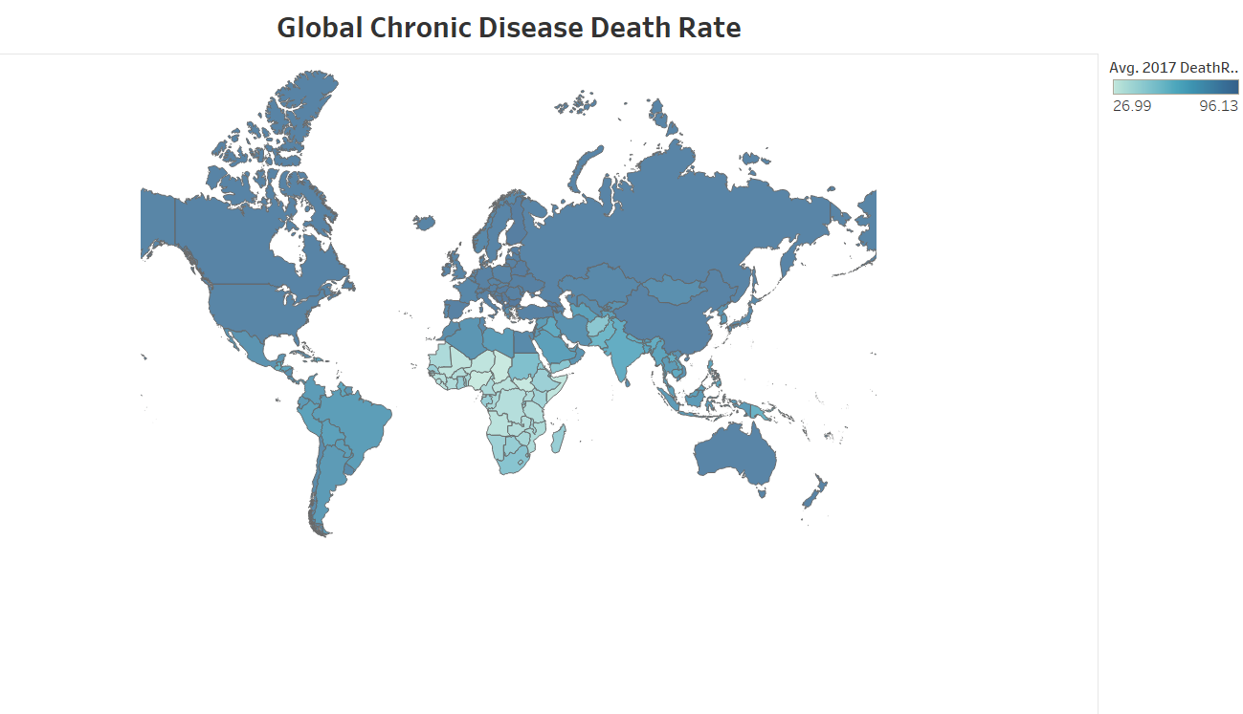
The visualization provides a global perspective on chronic disease death rates across different countries, focusing on data from the year 2017. A notable pattern emerges as the countries with the highest chronic disease death rates are primarily situated in Eastern Europe and Central Asia. Following closely are North America and the Caribbean, indicating a significant impact of chronic diseases in these regions.

One key takeaway is the substantial variation in chronic disease death rates from country to country. This emphasizes the diverse health challenges faced by different regions around the world. Chronic diseases, encompassing conditions like heart disease, cancer, and stroke, emerge as the leading causes of death on a global scale. This underscores the widespread impact of these health issues across nations.

3.DEATH RATE ANALYSIS W.R.T STATE AND RACE:

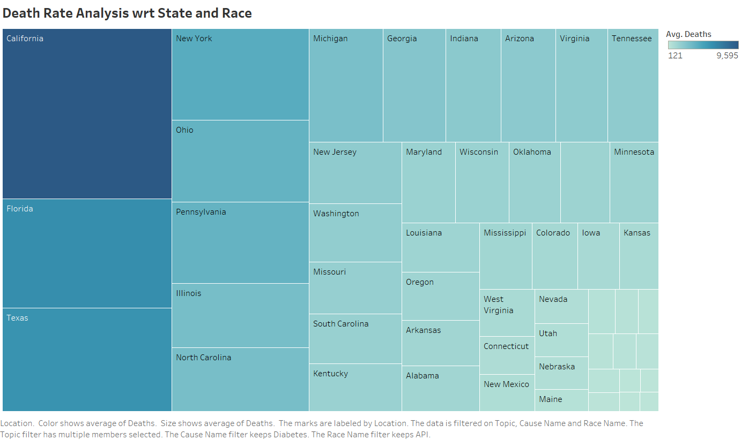

The revised analysis of the graph reveals some key insights about death rates in the United States. Firstly, California stands out with the highest death rate, closely followed by Florida and Texas. On the flip side, Alaska, District of Columbia, Wyoming has the lowest death rates, showcasing a notable variation across states.

Digging deeper into demographic factors, the analysis highlights variations in death rates among different racial and ethnic groups. African Americans and Native Americans experience higher death rates compared to whites and Hispanics.

In Addition to that, this visualization is interactive as we can change the race and cause name and extract meaning full data needed from this Heat map.

This heatmap analysis provides valuable insights into the complex landscape of death rates in the United States. Recognizing these patterns can guide targeted public health interventions to address specific challenges faced by different states and demographic groups, ultimately contributing to improved health outcomes nationwide.

4. PROPORTION OF CHRONIC DISEASE CAUSE NAME W.R.T AGE ADJUSTED DETAH RATE:

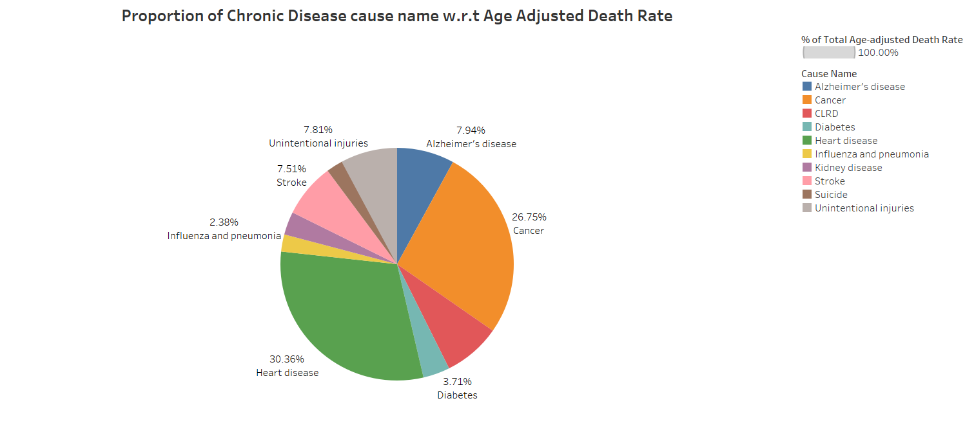

The pie chart offers a comprehensive look at the primary causes of chronic disease deaths, revealing insightful patterns. Heart disease, cancer, and stroke emerge as the most prevalent contributors, collectively responsible for over 23% of all chronic disease deaths. Notably, Alzheimer's disease and diabetes also play significant roles, accounting for more than 8% of the total chronic disease deaths.

The distribution of chronic disease deaths, as depicted in the pie chart, presents an interesting perspective on how different age groups are affected. Among individuals aged 65 and older, heart disease takes the lead as the predominant cause of death. However, in the age groups of 45-64 and 15-44, cancer emerges as the leading cause of chronic disease death. This age-specific variation emphasizes the dynamic nature of health challenges across different stages of life.

Delving into specific percentages, heart disease, cancer, and stroke each contribute roughly 7-8% to the total chronic disease deaths. Infection and pneumonia, Alzheimer's disease, diabetes, kidney disease, and unintentional injuries also make significant contributions, highlighting the multifaceted nature of chronic diseases and the need for diverse approaches in prevention and intervention.

5. TOP 10 STATES IN THE US WITH HIGH AVG DEATHS:

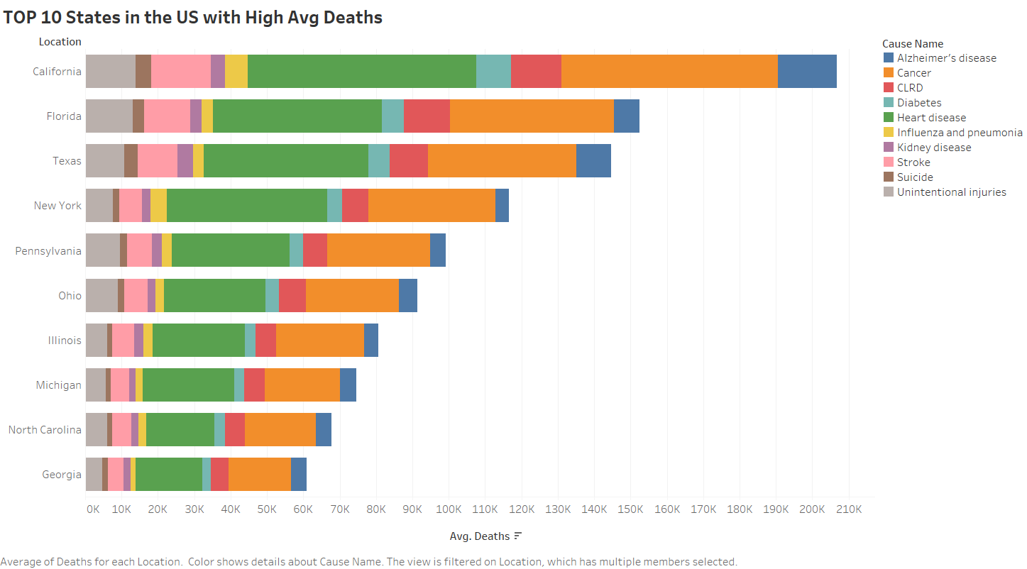

Looking at the top 10 states in the U.S. with a lot of average deaths, like California, Florida, and Texas, we see some important things. These states are mostly in the southern and midwestern parts of the country. People in these places are facing higher chances of dying on average.

The big reasons for this are chronic diseases, like heart problems, cancer, and stroke. These diseases are more common in these high-death states. It means we really need to focus on solving these health issues.

Also, where people live and how they live affects their health a lot. In these states with more deaths, there's often more poverty, fewer jobs, and more crime. These things make it harder for people to stay healthy. It shows that the conditions where people live and work play a big role in how long they live.

People in these states also tend to have habits that aren't so good for health, like smoking and being overweight. Getting good healthcare is also not as easy in these places, and there might be problems like dirty air.

CHRONIC DISEASES DASHBOARD 1:
The Chronic Disease Dashboard is not just a passive display of information; it invites users to actively explore and engage with the data in a way that is both intuitive and personalized. The interactive features of the dashboard allow users to dynamically adjust parameters, bringing a level of customization to the exploration process. For instance, in the section analyzing death rates by state and race, users can change race and cause names, tailoring the information to match their specific interests or research queries. This hands-on approach transforms the dashboard into a dynamic and user-driven tool for exploration.

The first visualization on the dashboard offers insights into chronic disease deaths across U.S. states. Notably, California, Florida, and Texas display higher rates, while Vermont, North Dakota, and Utah show lower rates. This map provides a clear overview of regional disparities in chronic disease burdens, laying the groundwork for understanding the geographical distribution of health challenges.

Moving beyond geography, the second visualization delves into death rates by state and various racial and ethnic groups. California stands out with the highest death rate, closely followed by Florida and Texas. The interactive heatmap allows users to explore nuanced variations by changing race and cause names. This feature transforms the visualization into a dynamic tool for dissecting disparities, highlighting how different demographics are affected by chronic disease.

The pie chart visualization breaks down major contributors to chronic disease deaths. Heart disease, cancer, and stroke emerge as the predominant causes, collectively constituting over 23% of all chronic disease deaths. The age-specific analysis reveals distinct patterns, highlighting that heart disease is more prevalent among older individuals, while cancer takes the lead in younger age groups. This visualization distills complex data into an easily digestible format, offering a clear understanding of the primary causes and their age-related implications.

The fifth visualization zeros in on the top 10 states in the U.S. with elevated average deaths, featuring states like California, Florida, and Texas. It effectively encapsulates the interplay of chronic diseases, living conditions, and lifestyle factors, illustrating the health challenges faced by residents in these specific regions. The visualization succinctly underscores the influence of factors like heart problems, unhealthy habits, and limited healthcare access, offering a brief yet potent overview of the elements contributing to higher average deaths in these states.

ADDITIONAL VISUALIZATIONS:

6. AVERAGE DEATHS W.R.T LOCATIONS:

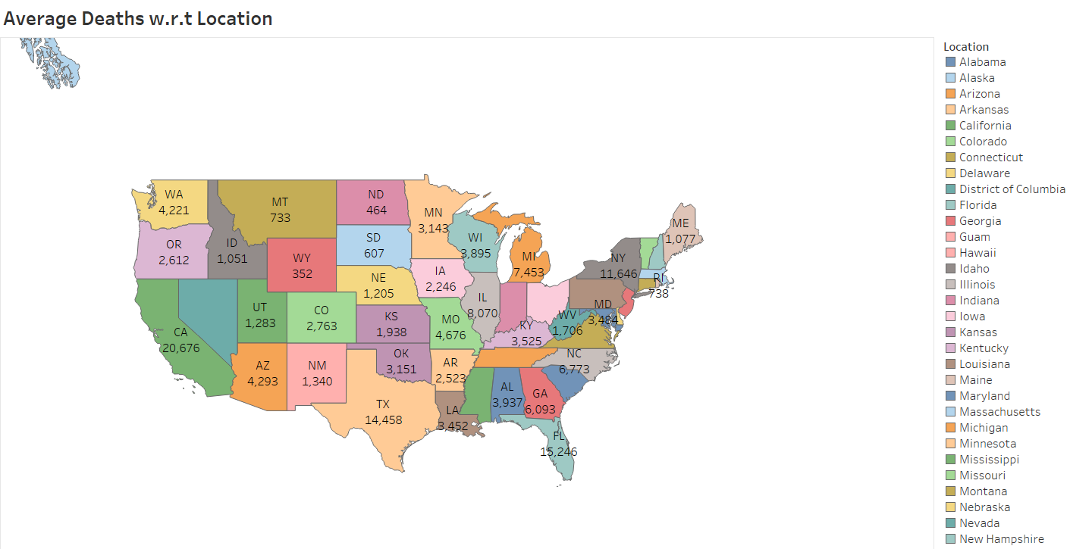

The visualization of average death rates across the United States highlights distinct regional patterns that underscore the profound impact of geographical location on health outcomes. Notably, states situated in the southern and midwestern regions consistently exhibit elevated average death rates, in stark contrast to their counterparts in the west and northeast. This geographical divide implies the presence of underlying systemic factors contributing to health disparities, emphasizing the need for region-specific interventions. The correlation between location and mortality rates prompts a critical examination of the social determinants of health, revealing a complex interplay of socio-economic factors that demand targeted public health efforts.

7.TOTAL DEATH RATE BY EVERY REGION AND THEIR INCOME GROUP:

The graph illustrating average death rates in the United States by state, income group, and region underscores a notable trend: the European region exhibits the highest average death rate, surpassing the national average. Several potential factors may contribute to this disparity. One conceivable explanation is that the European region has a higher proportion of older adults compared to other U.S. regions. Given that older adults are more prone to mortality, an increased percentage of this demographic could contribute to an elevated overall death rate in the region.

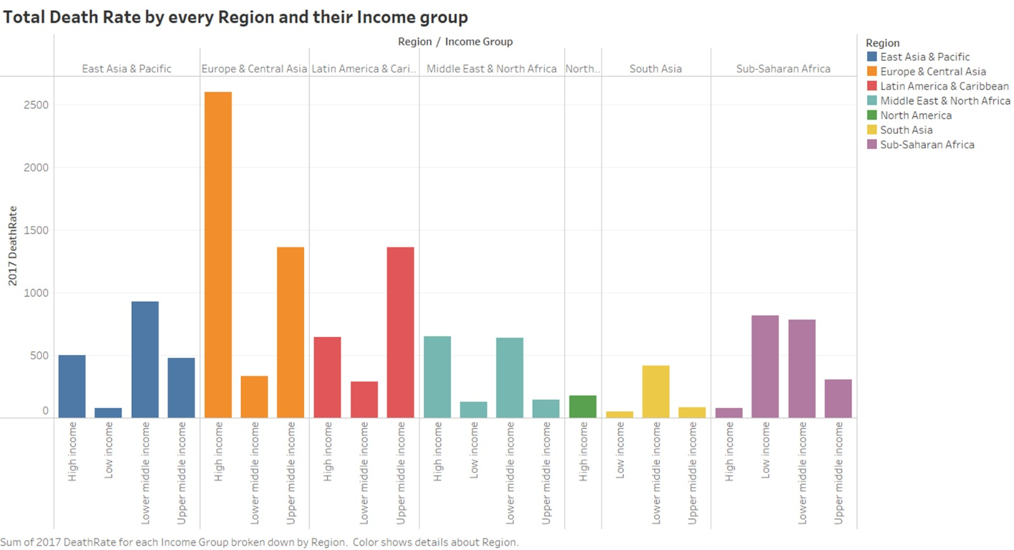
I have created the Hierarchy for the Region and Income Group when I drill down the region I can see the income group categories like high income, lower middle income and upper middle income for every region. This offers a detailed look at global economic trends. When we narrow down our focus to regions like North America, Europe, and Asia, breaking them into income categories such as high income, lower-middle income, and upper-middle income provides a closer examination of economic differences. This setup lets us understand the diverse economic situations within each region. For instance, in North America, we can study both high-income nations like the United States and those in the lower-middle-income bracket. Beyond just analysis, this hierarchy guides decision-making and policymaking, helping identify regions with specific income challenges and informing how resources are allocated and interventions are designed.

8.TOTAL DEATHS BY CAUSE THROUGHOUT USA:

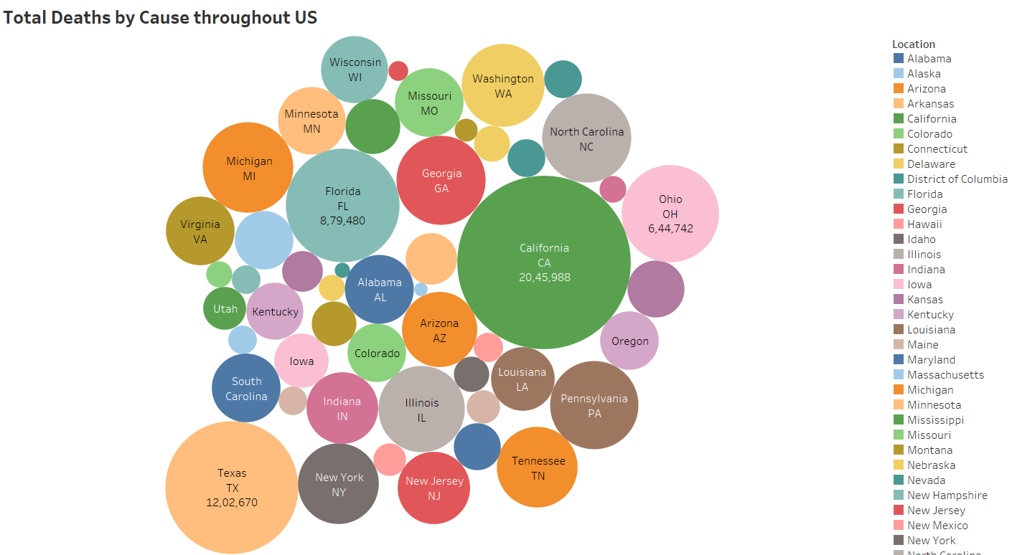

The graph is a packed bubbles chart depicting total deaths by cause throughout the United States in 2017. The chart effectively utilizes color to represent different causes of death, and the size of each bubble corresponds to the total number of deaths for that specific cause. Heart disease emerged as the primary cause of death in 2017, constituting over 25% of all deaths, followed closely by cancer and unintentional injuries. The chart further delineates that certain causes of death exhibit age-related patterns, with heart disease more prevalent in older adults and unintentional injuries more common among the younger population. This visual representation serves as a comprehensive tool for quickly grasping the leading causes of death and their age-specific variations. I have included the cause name as a parameter made the visualization interactive and each time you change the parameter the bubble chart shows the relevant information accordingly.

9. CHANGE IN DEATH RATES BY REGION AND INCOME GROUP:

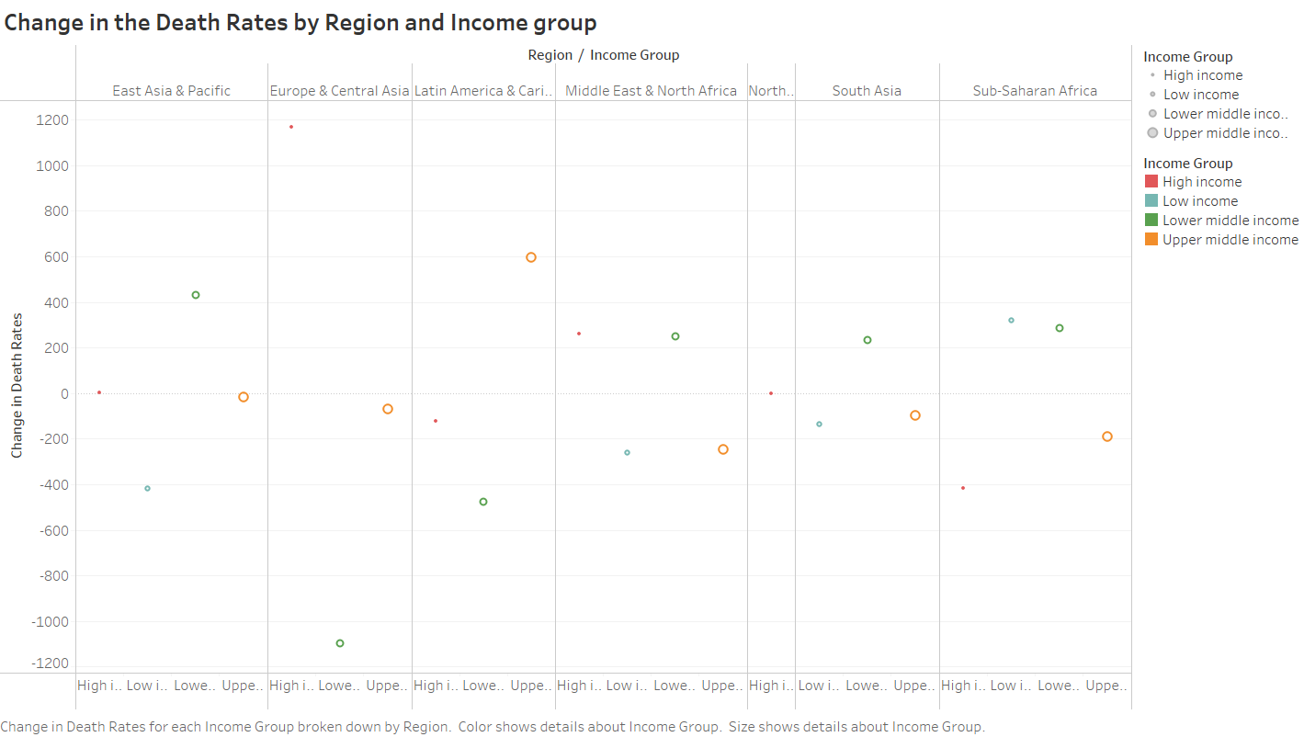

The scatterplot illustrates how death rates have changed over the time in different parts of the world and income groups. Generally, death rates have gone down globally, but the speed of this decline varies. East Asia & Pacific and high-income groups have seen the fastest improvement, while Sub-Saharan Africa and low-income groups show slower progress. The scatterplot emphasizes a clear link between income levels and the rate of change in death rates, with wealthier groups experiencing a faster reduction. This suggests that factors like poverty and access to healthcare significantly influence how quickly death rates improve.

10.TOTAL DEATHS W.R.T THE AGE RANGE AND THE RACE:

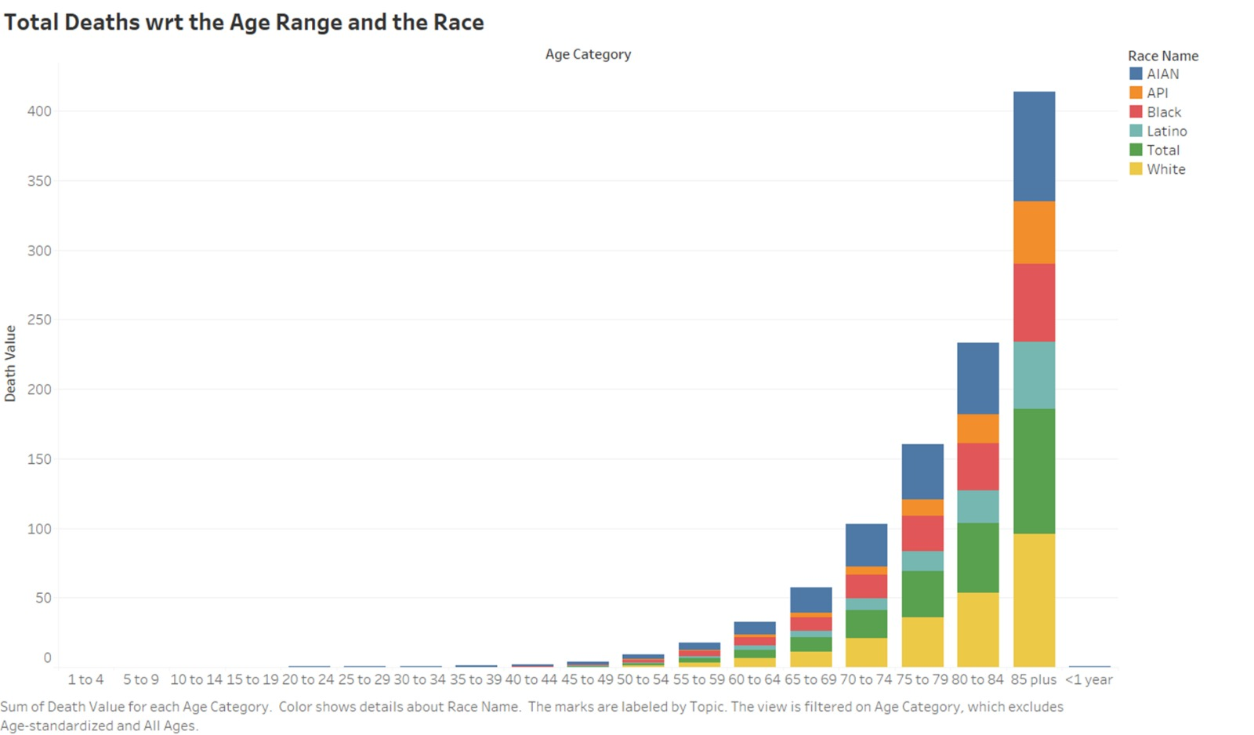

The bar graph depicting average death rates for all causes in the United States by age group and race reveals distinct patterns. There is a consistent increase in death rates with age across all racial groups, underscoring the association between age and mortality. Notably, Black Americans consistently exhibit higher death rates compared to White and Hispanic Americans across all age brackets, emphasizing the existence of significant racial disparities in mortality. Additionally, the graph highlights a consistent trend of higher death rates for men compared to women across all age groups, pointing to a gender disparity in mortality risk.

CONCLUSION:

In conclusion, our analysis of chronic diseases in the United States during 2017 has revealed several key insights. Firstly, we observed a notable prevalence of chronic diseases across the nation, affecting individuals from various demographic backgrounds. Our data indicated that certain demographic groups, such as older adults and those with lower socioeconomic status, experienced a higher burden of chronic conditions. Regional variations were also evident, with specific geographic areas demonstrating elevated rates of certain diseases, pointing to the importance of localized health interventions.

Furthermore, our exploration into lifestyle factors highlights strong connections. This correlation underscores the significance of lifestyle choices in mitigating the risk of certain health conditions. However, further research is needed to dig deeper into the causal relationships and potential interventions for promoting healthier lifestyles at both individual and community levels.

Wrapping up this project, additional research questions emerge. For instance,

- What specific interventions are most effective in reducing the prevalence of chronic diseases in high-risk demographic groups?
- How do environmental factors, such as air quality and access to green spaces, influence the geographic distribution of chronic diseases?
- What things can we do to make sure everyone has the same chance to get help for their chronic health issues, no matter where they live or how much money they have?
- What things can we do to make sure everyone has the same chance to get help for their chronic health issues, no matter where they live or how much money they have?

Exploring these questions could provide valuable insights for targeted public health strategies and contribute to the ongoing effort to address the complex landscape of chronic diseases in the United States.

References:

- https://data.worldbank.org/indicator/SH.DTH.NCOM.ZS?end=2017&start=2017&view=map
- https://ghdx.healthdata.org/us-data
- https://www.cdc.gov/chronicdisease/data/indicators.htm
- https://catalog.data.gov/dataset/u-s-chronic-disease-indicators-cdi
- https://ckan.publishing.service.gov.uk/dataset/deaths-from-respiratory-disease

